Remove Expired Inventory
The “remove expired inventory” feature allows you to remove inventory that has expired. Since you cannot dispense expired medication, this workflow must be followed to remove it from the system and inventory counts.

Short Form Workflow: To reconcile inventory, please follow the below:
- Press “Inventory”
- Press “View”
- Press “Expired” card
- Press specific card of item you want to remove
- Press “Remove Selected”
- Use dropdown to provide reason for removal
- Press “Remove”
- Confirm Remove, Press “Yes”

Detailed Workflow:

- You can choose what inventory to remove via the Inventory View screen. Press “Inventory”. Press “View”. The screen will separate inventory by status and program. Press “Expired”.

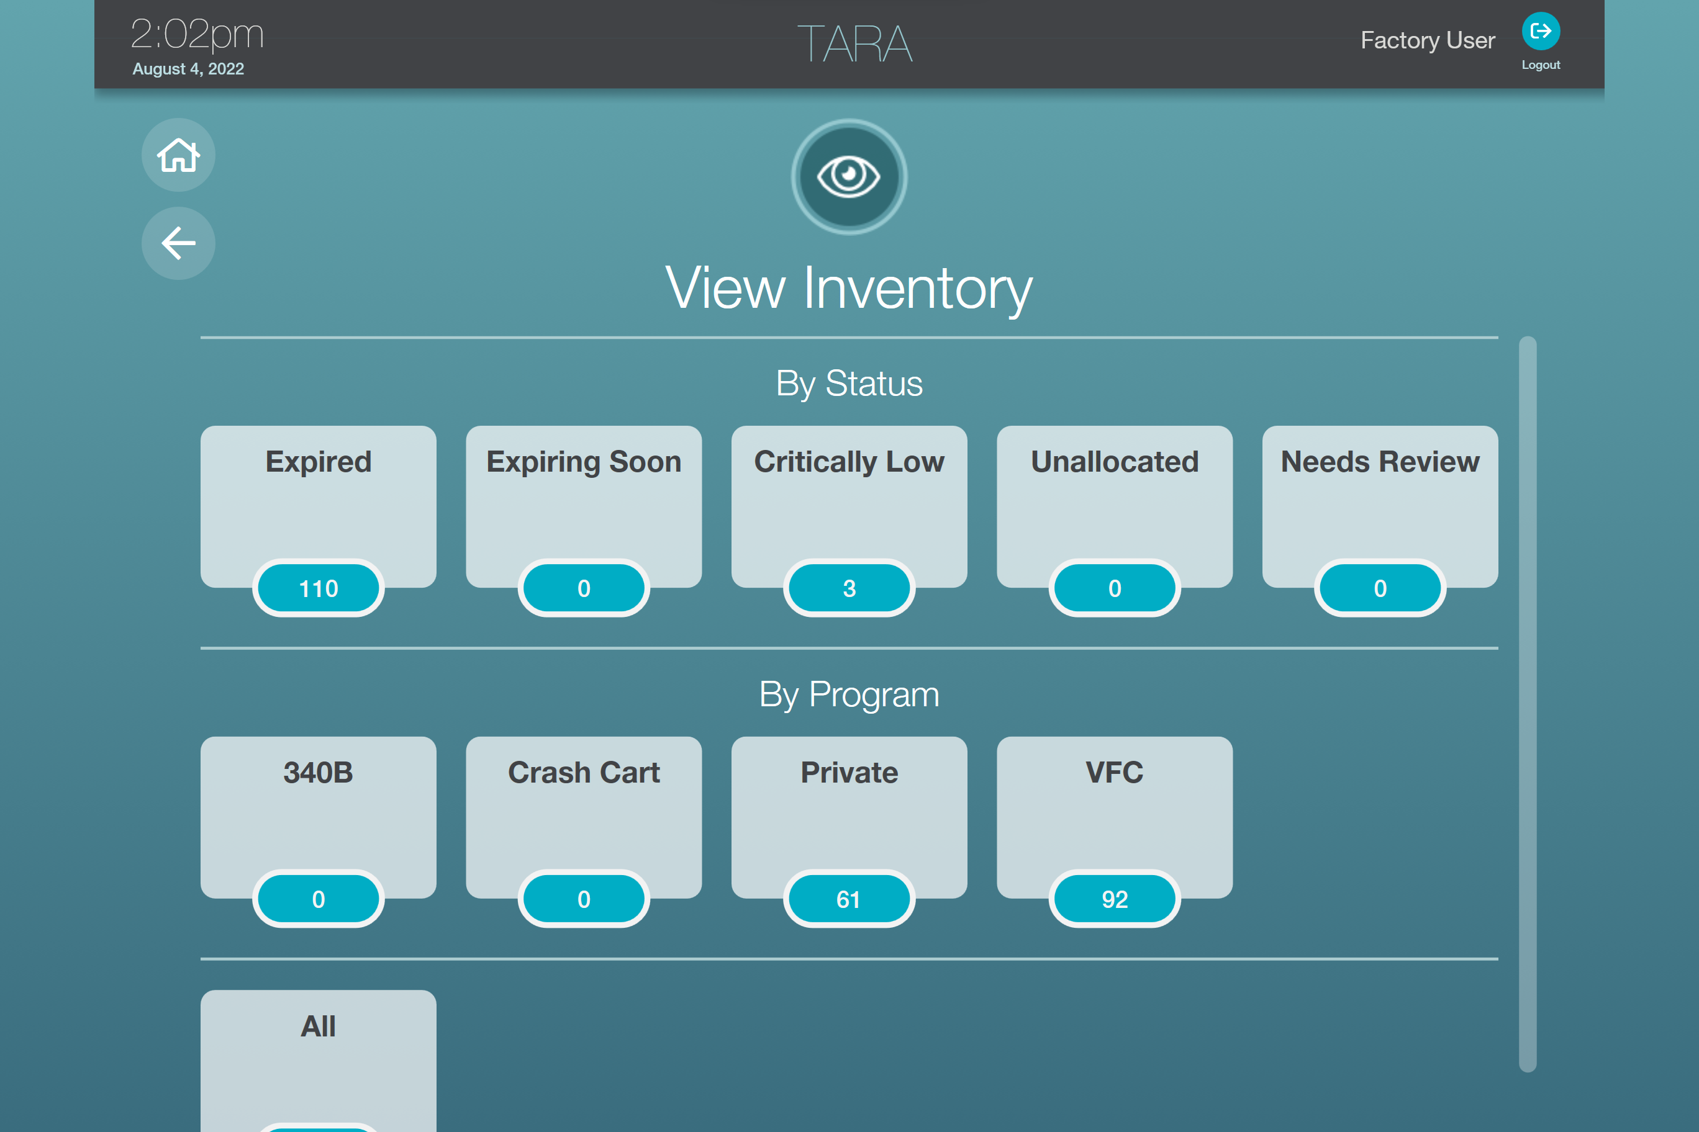

- The screen will populate with the available inventory cards for expired items. Press the cards for items that you want to remove. They will turn to a darker shade of blue. Once the item(s) are selected, press the “Remove Selected” button.

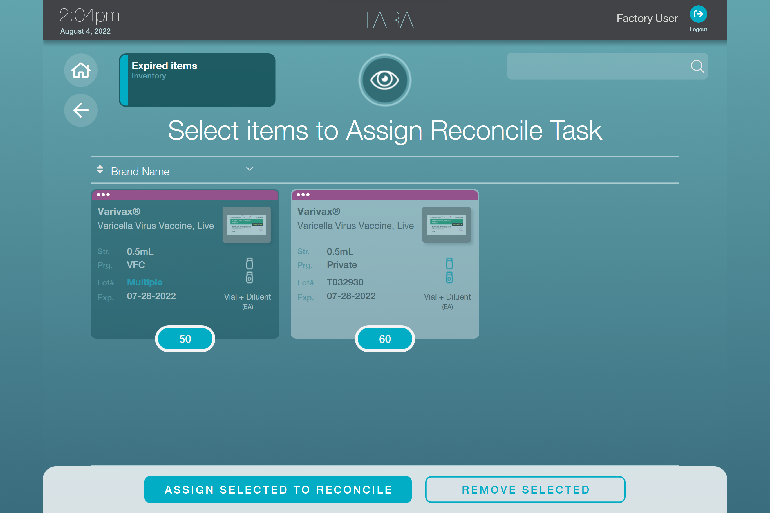

- Once “Remove Selected” is pressed you will need to provide a reason for item removal from the dropdown. In this case, choose “expired”. Press “remove selected”.

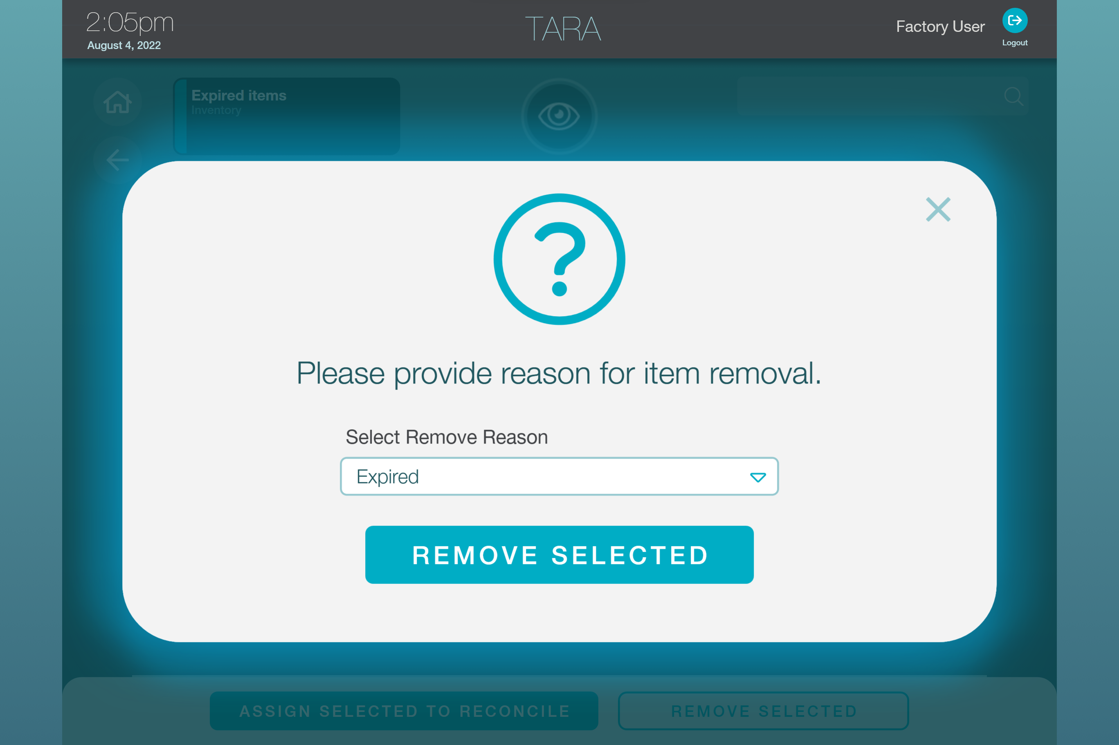

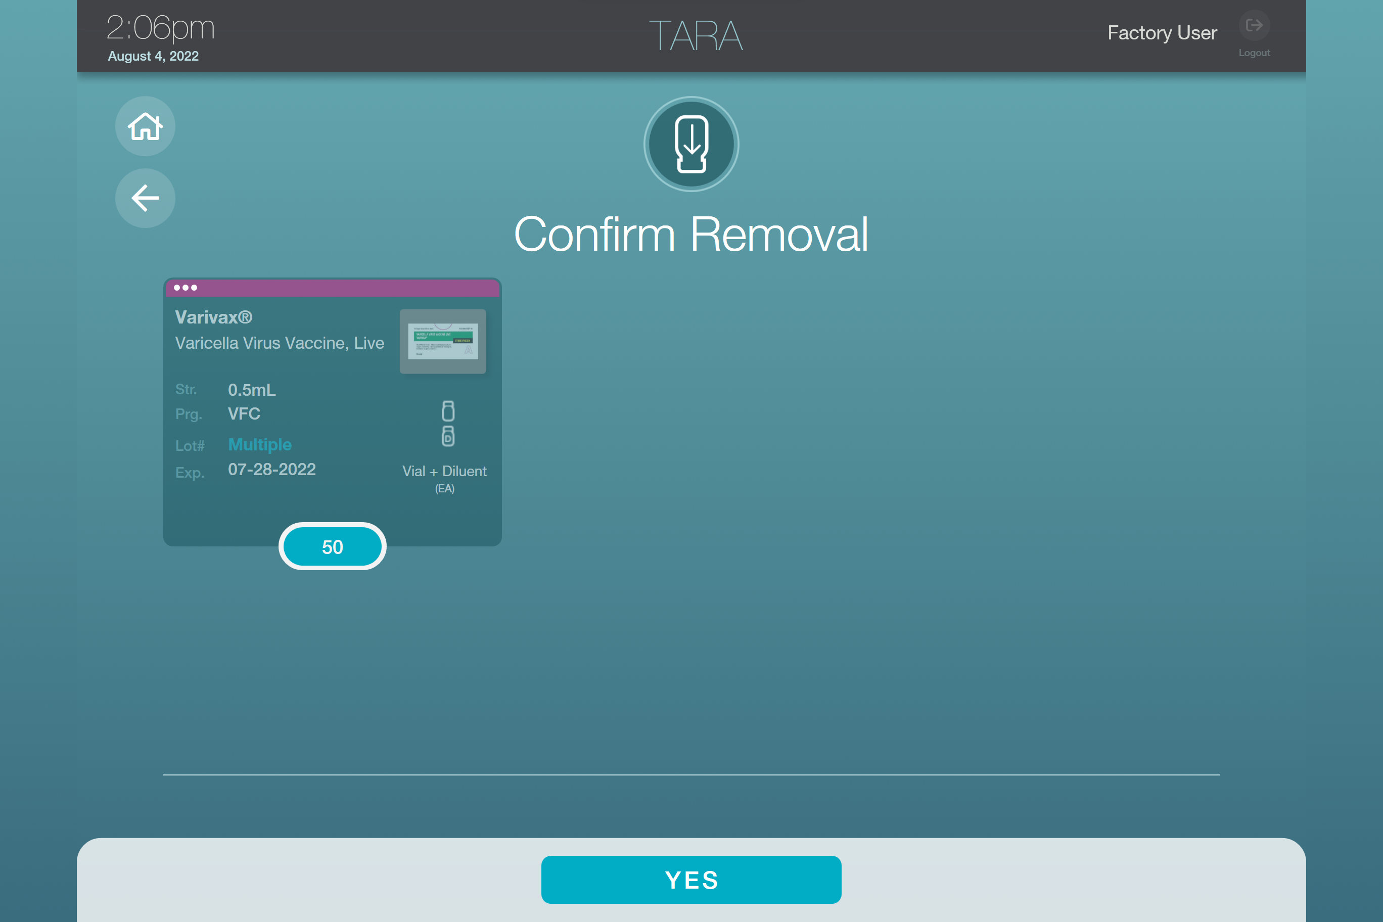

- Once the remove selected button is pressed, you will need to confirm removal. Press “Yes” on the bottom of the screen.

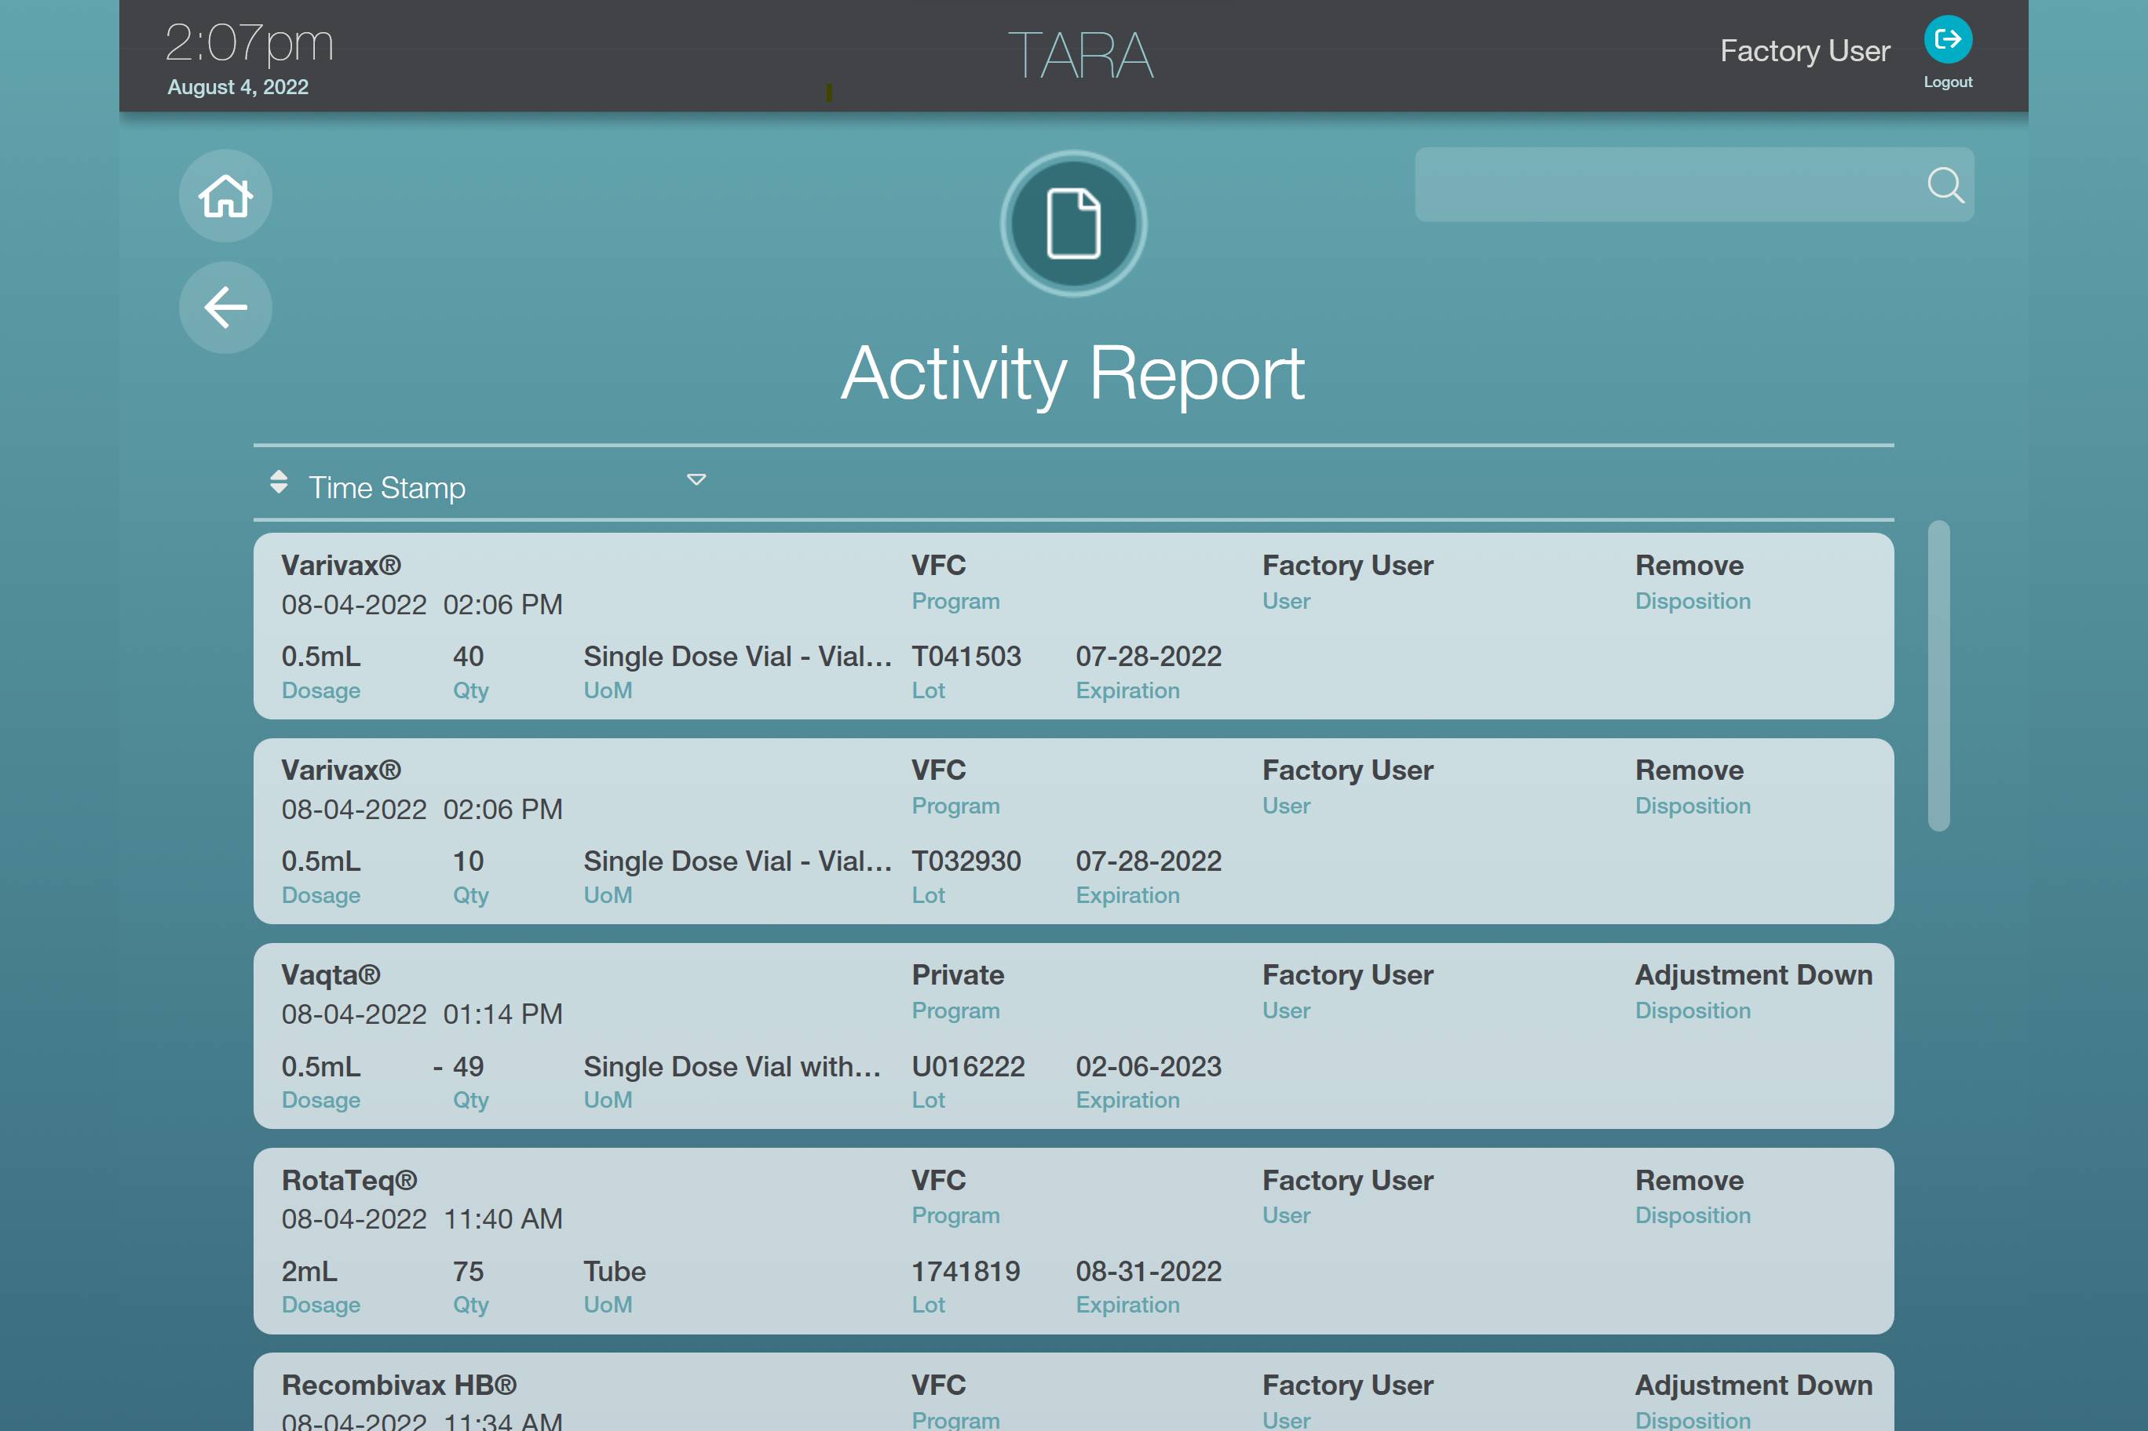
- Once confirmed, the inventory counts and statuses will be updated. The activity will be logged in the Activity Report. To view this report, press “Inventory”. Press “Activity”.

*Note: You can use the “remove” feature for any inventory that is tracked in the system. For example, if you want to remove items that are expiring soon, follow the process above, but choose a different reason for removal on the dropdown.

